**Chapter 1**

**Introduction**

This project is an interface, which interpreters the human hand movement to control pointer on screen and some gestures to execute applications.

Computers are the key elements of our society. It’s working speed and accuracy is very powerful. From beginning only, Computers are necessary everywhere. Computers are used to store and retrieve and process the data. People use it for typing letters, storing and transferring important data via internet, entertainment and playing games. Cost of the computer is decreasing and features are increasing day by day. They are becoming cheaper and effective so that everyone is intended to have a computer. Direct manipulation of graphic objects such as icons and windows using a pointing device is a very easy way to interact with computer and utilize it more. Keyboard, Mouse, Microphone and Camera are necessary input devices. In other areas where 3D information is required, such as Computer Games, Robotics and Artificial Intelligence and Designing, some special devices are used data-gloves joysticks.

**1.1 Problem Definition**

There are many types of keyboards like embedded keyboard, folder-keyboard and mini-keyboard exists in today’s market. However, these input devices need some amount of space to operate and it is not mobile [2].

Touch screen are also globally used which are good control interface and are being used in many applications like mobile displays, tablets and laptops. But touch screens related features like swipe or slide are not applicable to older desktop systems because of cost and other limitations in hardware. Use of vision technology, colorful markers (substance), image comparison technology and controlling the mouse by natural hand gestures, we can reduce the work space required [2].

Even if the invention of keyboard and mouse is a great progress, but there are some consequences in which these devices can be seen as dinosaurs of HCI. This is particularly the case for the interaction with 3D objects. The 2 degrees of freedom (DOFs) of the mouse cannot properly emulate the 3 dimensions of space [3].

**1.2 Domain**

It is not necessary to have Technical Knowledge but Domain Knowledge is must. From the list of project domains, Human Computer Interaction and Image Processing are the two domains of this project.

**1.2.1 Human Computer Interaction**

To improve the Computer technology, only computation and processing is not necessary but with that good design and user interface is also necessary. Human Computer Interaction (HCI) deals with this problem. In today’s technology, devices are getting smaller and smaller i.e. from desktop pcs to the smart watch but ease of use is maintained by the HCI only [2].

Human-computer interaction can also be defined as “some predefined rules that has to be followed to design, evaluate and implement interactive computing system for human use and also study of major concepts surrounding it.”

Goal of HCI:

a. Improve the interactions between Machine (Computer) and Customer (User)

b. Make the computers more efficient and simple for user to use.

**1.2.2 Image Processing**

Image Processing, as name suggest, it is nothing but improving or enhancing the image captures by the camera. This process is basically a subjective i.e. the photo edited by users differently. Also according to the use and processing sped different compressing algorithms are used. It converts a view into a digital copy.

In this project, video input is divided into number of frames i.e. images and to deal with this images to take detect and track the gestures, Image Processing is necessary. It also contains some algorithm predefined to remove noise [6].

The specifications of Image Processing are divided as follows:

a. Visualization: Objects which are Invisible to the human eye can be observed.

b. Sharpening and Restoration: I order to get better image, it get sharpened and restored.

c. Image Retrieval: Looking for the interested images.

d. Measurement of Pattern: It is possible to measure particular object from an Image.

e. Image Recognition: Identification of different objects from images [29].

**1.3 Gestures**

Generally, Humans move their hands as they talk i.e. the gesture. Gestures are somewhat unique, changes with respect to the culture, age, and operations performed. We can say Gestures are hereditary [4].

Gestures are direct and obvious body language signals. Waving and pointing in the air, and use fingers while counting are all very common and easy to understand gestures. Gestures may be cultural also, so giving a thumbs-up or a peace sign might have a totally different meaning from country to other country.

Some examples of Gestures those are easy to guess:

a. Clenched Fist: Anger or Solidarity.

b. Thumbs Up and Thumbs down: approve and disapprove.

c. Touch the thumb and index finger together in a circle while extending the other three fingers: OK. In some parts of Europe same signal is used to imply you are nothing and in South American it is actually a vulgar gesture.

d. By lifting the index and middle finger and separating them to create a V-shape: ‘peace’ or ‘victory’ [20].

The use of hand gestures provides an attractive alternative to these keyboard & mouse interface devices for human-computer interaction (HCI). User’s generally use hand gestures for expression of their feelings and notifications of their thoughts. Vision and sound are two important medium of communications. Hence man and machine interaction would be simpler if it made greater use of gesture recognition with video and audio recognition. One more advantage is that with distance communication, user need have to be in physical contact with the computer. In audio communication, user has to be in contact with microphone but in a visual system which is very preferable, can be use noisy environments or in situations where sound would cause a disturbance.

The areas for gesture recognition system:

a. Future system will be more feasible and user friendly as compared to the traditional command based or device based.

b. Gestures for virtual and augmented reality applications have experienced one of the greatest levels of uptake in computing. This concept will be used for interactions with 2D display that simulates 3D interface and real 3D displays [20].

c. Vision Based Gestures will become one of the best Gaming Tool available for every device.

d. Sign Language can be implemented for all Computing Devices.

e. Many 2D and 3D Image Developing software will use this technology as an important tool. AutoCAD, Solid work, Maya-Max like softwares where Designers get the freedom to create 3D objects easily.

**1.4 Project Summary**

In order to implement this project, data about hand i.e. controlling object is necessary. There are two technologies which are Glove Based and Vision Based. Vision based is the required one. Vision Based Technology also uses two types of detection technology i.e. Marker Based and Marker Less.

A Marker Based is chosen, since this is more practical, easy and robust with respect to the environment. The basic idea behind this approach is explained in Chapter 4.

First step in any object recognition program is the collection of the targeted object information. In this project, the RGB values of the marker are recorded for detection in every frame. Following to this operation, next one is Hand Gestures recording and storing then in storage for further Gesture Recognition Process.

Once the data has been collected then every video frame from Webcam Input is get recognized for detection of Marker and Gesture from Storage.

Finally the pointer’s locations are getting controlled using this location and also the execution of application is done. Chapter 4 deals with this step.

**Chapter2**

**Review of Literature**

The main idea behind this project is to create User Interface which can identify Human Finger and Hand Gestures to convey information and control applications. Basically there are two types of approaches which are commonly used to interpret gestures for Human Computer Interaction and they are Glove based and Vision Based.

**2.1 Data Glove Based Approach**

This technique employs sensors (mechanical or optical) attached to a glove that transduces finger flexion into electrical signals for determining the hand posture. User has to wear a glove in hand. This glove is connected to computer with cables and inside that glove there are some sensors used to measure the movement of fingers of particular gesture and interpret on computer.

But the problem is user has to carry a load of cables and hinders the ease and naturalness of the user interaction [3].

**2.2 Vision Based Approach**

Computer vision based techniques are non-invasive and based on the way human beings get information from their environment. Vision-based interaction is a challenging interdisciplinary research area, which includes computer graphics, processing of images, bio-informatics, machine learning, and the psychology [3].

There are some predefined features or properties in Human Hand position or its movement. They are useful in this approach to scan every frame of video input in order to track correct location and movement of respective object.

**2.3 Features**

Selecting features is critical for gesture recognition, as hand gestures are very rich in motion shape variation, and textures. For steady hand position recognition, although it is possible to recognize hand posture by extracting some geometric features such as fingertips, finger’s directions etc. Such features are may not be available and reliable due to self-occlusion and lighting conditions. Features can be classified as Model Based, View based and Low Level Feature based.

Model based Approaches (Kinematic Model):

Pose of the palm and joint angels are the two main key points of this approach. This approach consists of searching for the kinematic parameters that brings the 2D projection of a 3D model of hand into correspondence with an edge-based image of a hand [3].

The drawback is extraction of features. The human hand itself is rather texture less and does not provide many reliable edges internally. The edges that are extracted are usually extracted from the occluding boundaries [5]. Sometimes due to light and shadow, this approach will not work as required and can create problems.

View based Approaches:

Kinematic approach is very difficult so an alternative approach that has garnered significant focus in recent years is view-based approach. This approach involves both spatial as well as temporal processing of image frames. Two important components of this concept are the tracking of the moving hand across frames and extracting the semantic interpretation corresponding to the gesture [3].

View based approaches, also referred to as appearance based approach models the hand by a collection of 2D images with different intensities. Gestures are identified from a sequence of views. [3].

Low Level Features based Approaches:

In many gesture applications, main thing is a mapping between input video and gesture. Therefore, many have argued that the full reconstruction of the hand is not essential for gesture recognition. Instead many approaches have utilized the extraction of low-level image measurements that are fairly robust to noise and can be extracted quickly.

This approach is very effective than all above approach. It’s also efficient for processing and execution on small processing computers also [3]. There are also techniques in which difference between two consecutive frames is calculated and according to that the moving object is get tracked.

**2.4 Detection and Tracking Algorithms**

Hidden Markov Models (HMM):

HMM deals with the dynamic gestures. These gestures are identified from frames i.e. a sequence of video images by tracking the skin color blobs corresponding to the hand into a body face space centered on the face of the user. The goal is to recognize two classes of gestures i.e. deictic and symbolic. The image is filtered using a fast look–up indexing table of skin color pixels in YUV color space. After filtering, skin color pixels are surrounded by blobs. Blobs are statistical objects based on the location (x, y) and the colorimetric (Y, U, V) of the skin colour pixels in order to determine homogeneous areas. A skin colour pixel belongs to the blob which has the same location and colorimetric component [6].

YUV Colour Space and CAMSHIFT Algorithm:

This method deals with recognition of hand gestures. It is done in the following steps.

Step 1: A digital camera records a video stream of hand gestures.

Step 2: All the frames are taken into consideration and then using YUV colour space skin colour based segmentation is performed. The chrominance and intensity are separated by using the YUV colour system. Here, Y is intensity symbol and UV specifies components of chrominance.

Step 3: Now the hand is identified using CAMSHIFT algorithm .Hand is the largest connected region so we can segment the hand.

Step 4: After this is done, the position of the hand centroid is calculated in each frame. This is done by first calculating the 0th and first moments and then using this information the centroid is calculated.

Step 5: Now the different centroid points are joint to form a trajectory .This trajectory shows the path of the hand movement and thus the hand tracking procedure is determined [6].

NEURAL NETWORK APPROACH:

Neural networks are composed of elements, called neurons, which are inspired by biological nervous systems of the animals. Neural Network Elements forms networks and operates parallel. Their function is determined largely by the connections between them. Neural networks have received much attention for their success in pattern recognition and gesture recognition. This algorithms are popular because once the network has configured, it forms appropriate internal re-presenter and decider systems based on training examples.

Neural networks are useful to solve many problems. Artificial Neural Network (ANN) is used to get solutions in easy and convenient manner. It is similar to Human Nervous System. Noor and Khan proposed a review, in which they analyses Artificial Neural Networks for Hand Tracking and Gesture Recognition [7].

**Chapter3**

**Proposed System**

This project is designed for windows platform and according to that particular softwares are used. Project is based on Marker based technology algorithms are used by considering this approach. The detail explanation is given in this chapter.

**3.1 Materials and Methods used**

Project system is working on Windows i.e. .NET technology. So its targeted windows platform is important to necessary to understand before the software discussion. Also Marker Based technology requires some very necessary hardware to implement the logic and algorithms.

**3.1.1 Targeted Platform of Program**

For this program the targeted platform i.e. the Operating System is Windows 7 and Windows 8/8.1. The Windows XP is excluded as it is outdated and service for Windows XP is discontinued by Microsoft.



**Figure 3.1: Logo of Microsoft Windows 7 [18]**

Windows 7 is a personal computer operating system developed by Microsoft. It is available from 5 years ago. It supports platform IA-32 and x86-64. Windows 7 has very attractive logo shown in above figure 3.1 [18]. It is printed on the machines which are working on this Operating System.

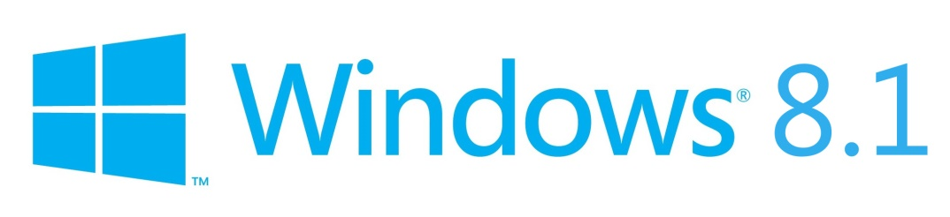

**Figure 3.2: Logo of Microsoft Windows 8.1 [17]**

Windows 8/8.1 is released 17 months ago by the Microsoft. It supports one more platform than Windows 7 which is ARMv7. It came with new features, new logo (as shown in figure 3.2) but the same interface like explorer and other applications [17]. It has new approach to install application i.e. the app store with millions of apps as well as older applications compatible with previous versions. This operating system is useful for Windows Desktops/Laptops, Mobile Phones and Tablets. So this system is planned to work on this platform. Right now it support only for Desktop and Laptop as the technology becomes paid to create apps for tablets and mobile phones.



**Figure 3.3: Logo of Ubuntu Operating System [16]**

Ubuntu is also very powerful operating system and it is open source. It is very popular and also totally different from Windows Operating Systems. There is similar projects ex. ‘Easystroke Gesture Recognition’, existing for this platform [16]. By installing some packages and writing some commands in Terminal, this project can also be executed on this platform i.e. Ubuntu as shown in above figure 3.3.

**3.1.2 Hardware and Software Used**

To execute this project logic, some hardware that must be gathers to use this project system. They are discussed here.

Two main hardwares are Camera and colored substance i.e. markers. With that computer, i.e. the device on which this project is executing is also explained briefly.

Computer:

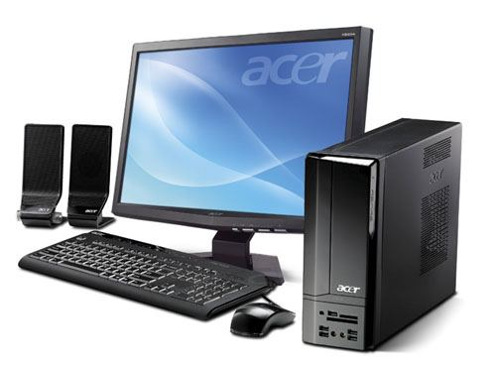

**Figure 3.4: Picture of Simple Desktop Computer of Acer Company**

Desktop Computer is chosen since this project is designed for desktop systems only. As we already discussed in problem definition from chapter 1, touch screens are being used in many applications like mobile displays, tablets and laptops. But touch screens related features like swipe or slide are not applicable to older desktop systems because of cost and other limitations in hardware. To overcome this problem i.e. the large work space required can be sort out in this project system [2].

The basic requirement of computer is Pentium4 Processor with processor Speed of 1GHz and 512 MB RAM & 40GB Hard disk. Monitor requirement is 15SVGA only. This system is designed to work effectively on any Computer. This project is implemented on similar requirements. As shown in figure 3.4, similar computer with specifications like Core i3Processor with Processor Speed of 2.30GHz, 2GB RAM and Hard disk: 500GB is used.

Camera:

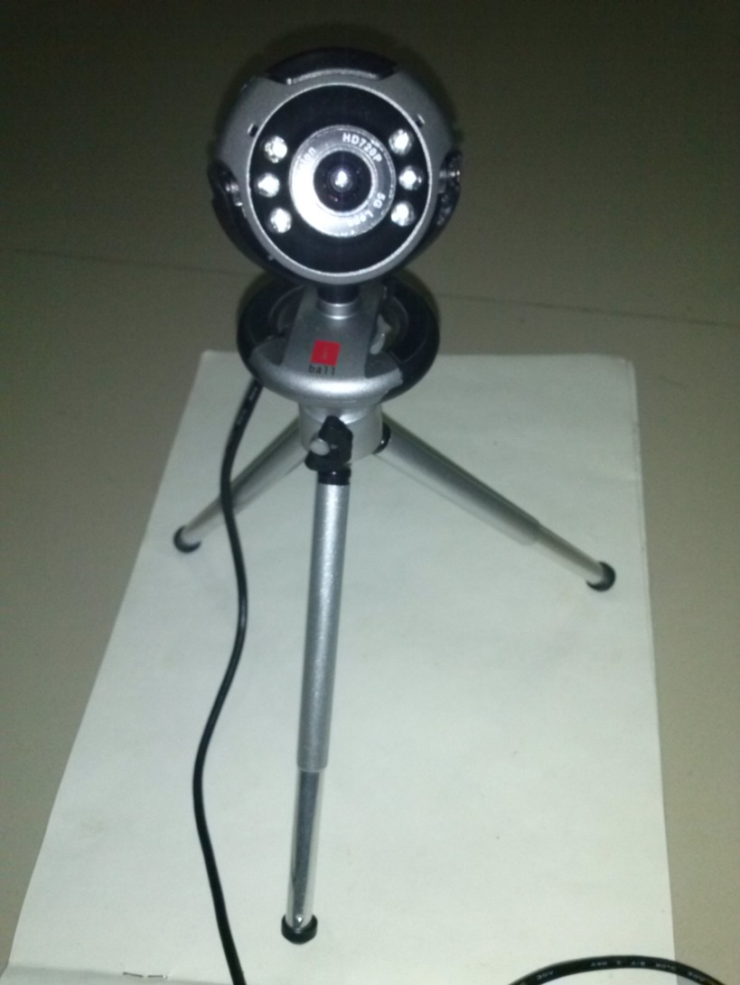

**Figure 3.5: Picture of i-ball CHD 12.0 Webcam**

CHD 12.0 i-ball webcam is used while developing this project and also to use this project system. It matches the basic requirements i.e. 12.24-bit RGB Video data format, Image resolution 640x480 is required. Frame rate is also 30 frames per seconds. As shown in figure 3.5, this webcam is High Definition (HD) with night vision feature and flash [15].

Markers / Color Substances:

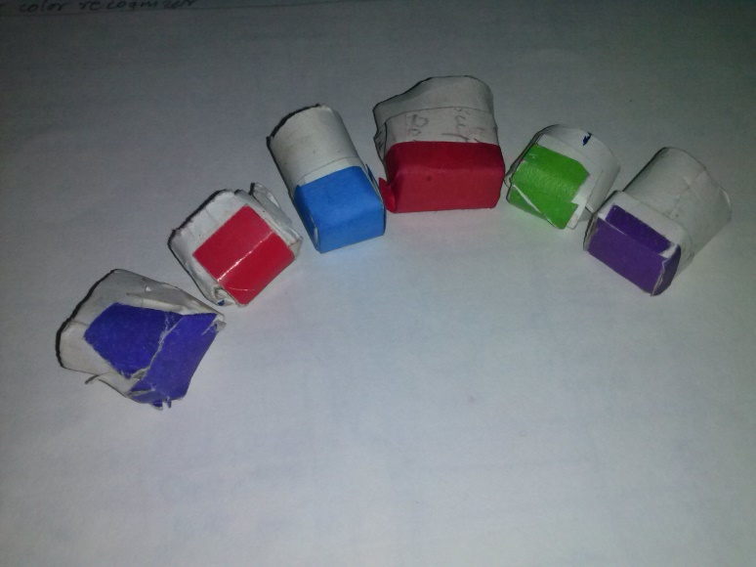

**Figure 3.6: Markers of different colors for finger tracking**

Basically Red and Blue colored substance is necessary but only one marker is used in this system of any color. Markers used in existing systems that are developed before are minimum 3 in different colors. But this creates problem of limited colors for 3 markers or limitation of environment. To solve this issue, only one marker is used so that numbers of colors possibility can be enhance to differentiate it from background colors as shown in figure 3.6.

Apart from softwares, to build this project, some softwares are used which are described as follows. To implement this concept, there is necessity of Computer Vision Environment based Softwares and Visual Studio 2010 or 2013.

Computer Vision Environment Softwares are:

NVIDIA CUDA:



**Figure 3.7: NVIDIA CUDA**

It uses parallel computing and processing and increases the graphic performance by harnessing the Graphics Processing Unit (GPU) Power. CUDA provides a toolkit and also CUDA C++ language [14]. Figure 3.7 is logo of NVIDIA CUDA software.

OpenNI



**Figure 3.8: OpenNI**

OpenNI is compatible depth sensors. It allows device to initialize sensors and get the RGB, depth and IR video streams. Proveid single interface [21]. OpenNI is identified by the logo shown in above figure 3.8.

AForge.NET



**Figure 3.9: AForge.NET**

AForge.NET is a C# framework designed for developers and researchers in the fields of Computer Vision and Artificial Intelligence - image processing, neural networks, genetic algorithms, machine learning, robotics, etc [13]. The new AForge.NET framework 2.2.5 release, which just became available for downloads.

Figure 3.9 shows logo of AForge.NET, which is a computer vision and artificial intelligence library originally developed by Andrew Kirillov for the .NET Framework. The source code and binaries of the project are available under the terms of the Lesser GPL and the GPL (GNU General Public License) [13].

OpenCV



**Figure 3.10: Logo of OpenCV**

OpenCV is an open source (see http://opensource.org) computer vision library available from http://SourceForge.net/projects/opencvlibrary. The library is written in C and C++ and runs under Linux, Windows and Mac OS X. There is active development on interfaces for Python, Ruby, Matlab, and other languages. OpenCV was designed for computational efficiency and with a strong focus on real time applications. OpenCV is written in optimized C and can take advantage of multicore processors.

Although Intel started OpenCV, the library is and always was intended to promote commercial and research use. It is therefore open and free, and the code itself may be used or embedded (in whole or in part) in other applications, whether commercial or research. It does not force your application code to be open or free. It does not require that you return improvements back to the library [8].

EmguCV



**Figure 3.11: Logo of EmguCV**

EmguCV is a cross platform .Net wrapper to the OpenCV image processing library. Allowing OpenCV functions to be called from .NET compatible languages such as C#, VB, VC++, Iron, Python etc. The wrapper can be compiled in Mono and run on Windows, Linux, Mac OS X, iPhone, iPad and Android devices.

**Table 3.1: Different versions of EmguCV**

|  |  |  |  |  |
| --- | --- | --- | --- | --- |
| Name | EmguCV (Open source) | EmguCV Commercial Optimized | EmguCV for iOS Commercial | EmguCV for Android (Beta) |
| OS | Windows, Linux, Mac OSX | Windows | iOS | Android |
| Supported CPU Architecture | i386, x64 | i386, x64 | armeabi, armeabi-v7, i386 (Simulator) | armeabi, armeabi-v7a, x86 |
| GPU Processing | Y | Y | N | N |
| Exception Handling | Y | Y | Y | Y |
| Debugger.Visualizer | Y | Y | N | N |
| Emgu.CV.UI | Y | Y | N | N |
| License | GPL | Commercial | Commercial | Commercial |

As show in above table 3.1, EmguCV (Open Source is used as it is use GPL license).

Advantages of EmguCV:

a. Cross Platform

EmguCV is written entirely in C#. The benefit is that it can be compiled in Mono and therefore is able to run on any platform Mono supports, including Linux, Mac OS X, iOS and Android.

b. Cross Language and comes with example code

EmguCV can be used from several different languages, including C#, VB.NET, C++ and IronPython.

Architecture Overview

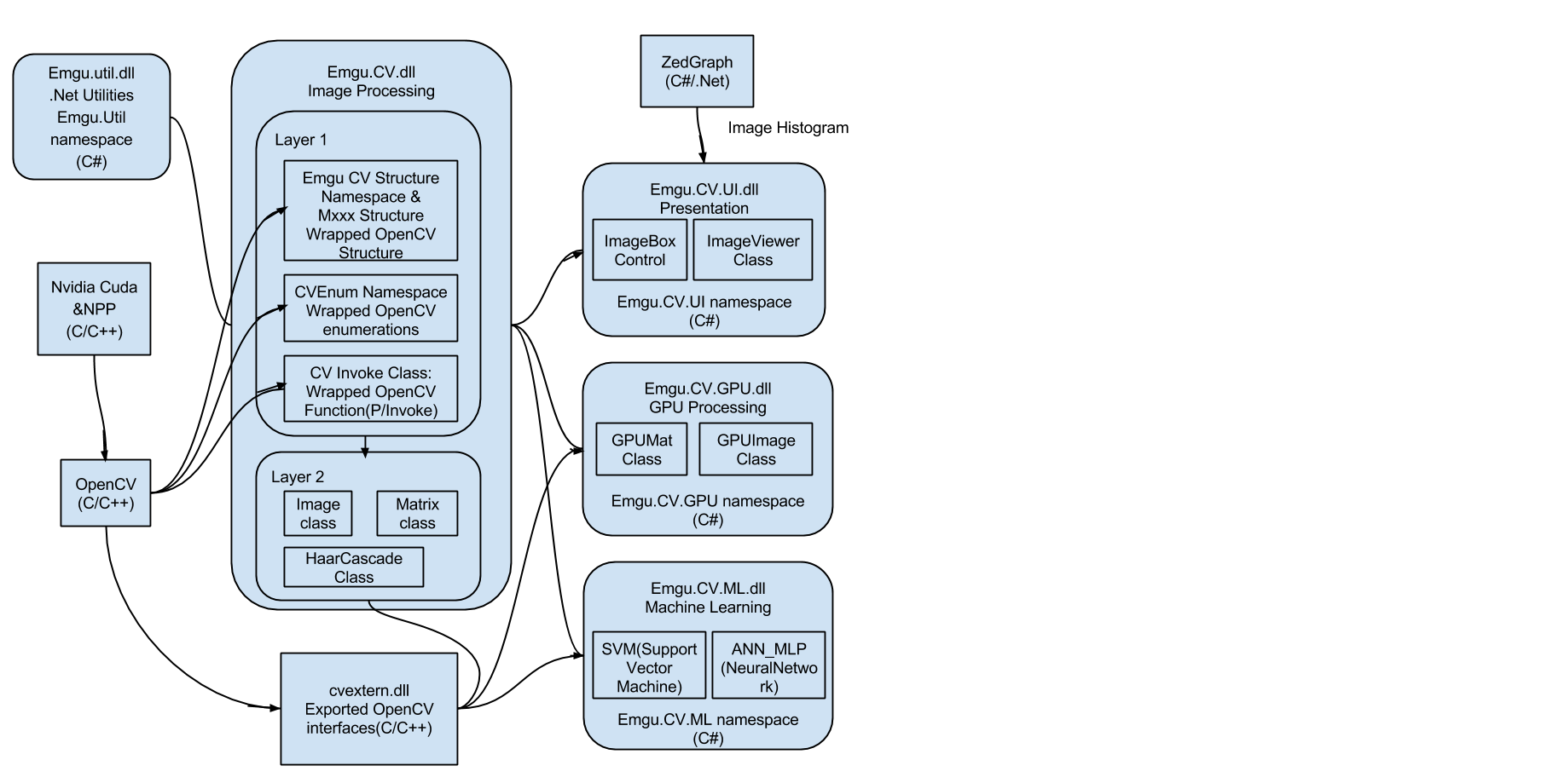

**Figure 3.12: Architecture of EmguCV**

EmguCV has two layers of wrapper as shown in figure 3.12.

a. The basic layer (layer 1) contains function, structure and enumeration mappings which directly reflect those in OpenCV.

b. The second layer (layer 2) contains classes that mix in advantages from the .NET world [19].

Reasons to select EmguCV Only:

EmguCV is just a wrapper which calls OpenCV methods from supported languages like C#, VB etc. Unlike other wrappers, it doesn't use unsafe code and is written purely in C# which makes EmguCV a way different, better and efficient than others.

Since the .NET technology is easier to develop and debug with all tools at one place, apart from any other technology like Java, Python.

Cmake



**Figure 3.13: Cmake [29]**

Cmake is the software that solves the problem of different .dll files incompatibility with different frameworks and platforms [29].

If there is source code available for the dll files, here EmguCV dll files, anyone can generate .dll files for their own system independently. This project is compatible with all possible platforms due to Cmake. Download free from any website with link inside the logo as shown in figure 3.13.

Visual Studio 2010 and .NET Framework 4 Training Kit



**Figure 3.14: Visual Studio [22]**

It is released in December 2011. The Visual Studio 2010 and .NET Framework 4 Training Kit includes presentations, hands-on labs, and demos. This content is designed to help you learn how to utilize the Visual Studio 2010 features and a variety of framework technologies including C# 4, Visual Basic 10, F#, Parallel Extensions, Windows Communication Foundation, Windows Workflow, Windows Presentation Foundation, Silverlight 4, ASP.NET 4, Windows 7 Entity Framework, ADO.NET Data Services, Managed Extensibility Framework, Application Lifecycle Management and Windows Azure.

This version of the Training Kit works with Visual Studio 2010 and .NET Framework 4. Supported Operating Systems are Windows 7, Windows Server 2008, Windows Server 2008 R2, Windows Vista [22].

This project is built in C#4 and EmguCV dll files in backend and Microsoft Form for front end. C#4 means C# in .NET Version 4. It is also possible to use OpenCV with C++ but here for C#, EmguCV invokes same methods by using ‘EmguCV.Invoke ()’ method.

EmguCV NuGet



**Figure 3.15: NuGet for EmguCV [23]**

There is also one solution in Visual Studio which known as NuGet. There is also a NuGet available for EmguCV but it is paid. NuGet simplifies the steps while setting up the environment to run these codes of Computer Vision [23]. This NuGet are works inside the Visual Studio. They copy the necessary files while debugging the project.

**3.2 Model Development**

In model development, brief information about architectural design and proposed working of this project is discussed.

**3.2.1 Architectural Design**

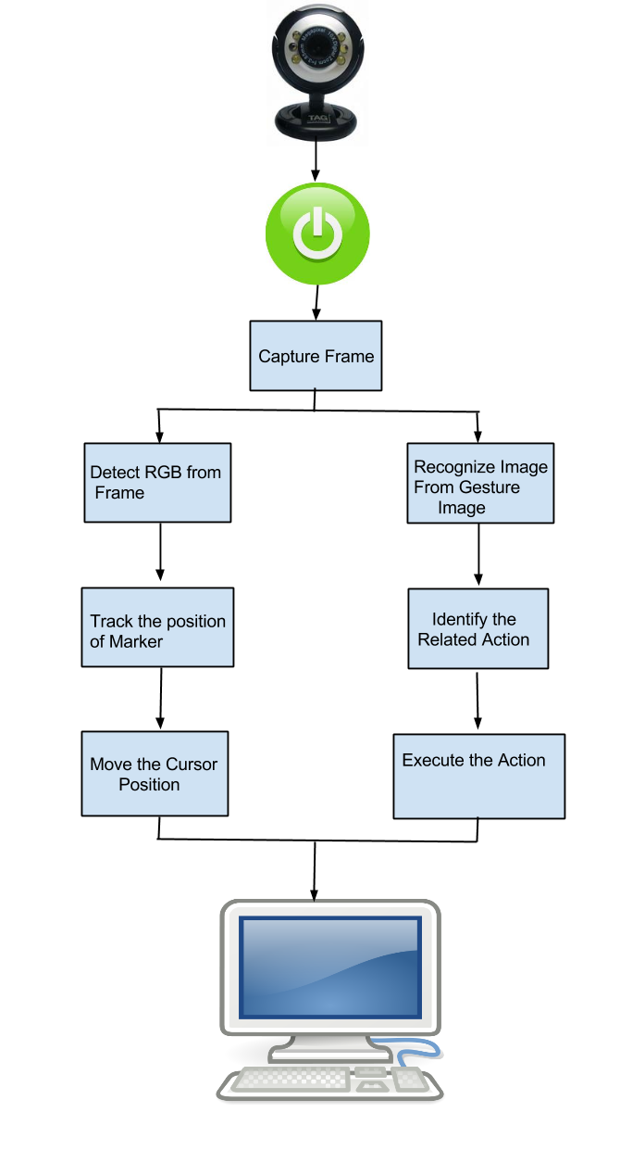

**Figure 3.16: Architectural Design**

Software application architecture is the process of defining a structured solution that meets all of the technical and operational requirements, while optimizing common quality attributes such as performance, security, and manageability. It involves a series of decisions based on a wide range of factors, and each of these decisions can have considerable impact on the quality, performance, maintainability, and overall success of the application. The architecture design of this project is given below in figure 3.16. It starts with Webcam which is the main input device. It captures the movements. Camera and its properties like resolution and brightness, camera focus, etc. are important to set before selecting it to start capture. Since every video consist of so many frames with proper speed i.e. Frames per Second (15 fps to 50 fps). Every frame is necessary to get processed for proper result. Object detection, Tracking and Recognition is done repeatedly for this system. Three of these blocks are implemented by building the software and according to the input, the result i.e. the execution of either application, operation or system task is get called.

Detection involves ‘Detect RGB from frame’, in which RGB values are retrieved from markers. The values from this steps are used to ‘Track the position of Marker’ in order to control cursor. Once you get the X and Y co-ordinates of detected marker then you can control the mouse easily.

Simultaneously, ‘Recognize Image from Gesture Images’ method is executed in parallel. Once it gives the identified gesture image then next task is to get proper action to be executed and these instructions are included in ‘identify the related action’ step. ‘Execute the Action’ is simply control all the actions that has to be executed in response.

Finally the result is displayed on ‘Screen’ as an output.

**3.2.2 Proposed Working**

Proposed working is the logic or all the steps that are used in this project. As shown in figure 3.17 the working flow is explained stepwise.

Step 1: Start Main Program

Execution of the project system is done by executing ‘DFGIFDS_CSharp_V2010.exe’. This will simply run the system by preparing the UI of Application and Initialize all the reference and DLL files used for this program. Main DLL files are given below that has to be there in system or necessary to install as software requirement for this project.

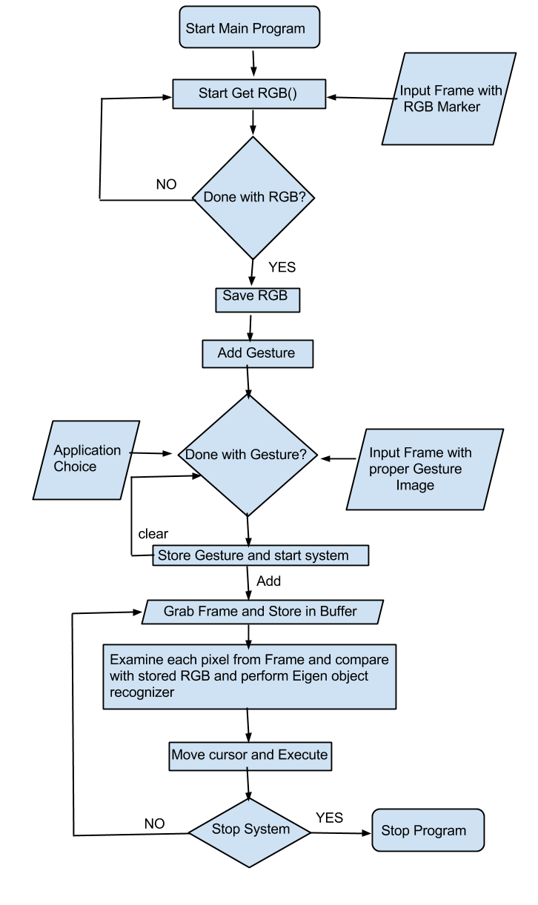

**Figure 3.17: Proposed Working**

a. Emgu.CV.dll

b. Emgu.CV.CvEnum.dll

c. Emgu.CV.Structure.dll

d. Emgu.CV.UI.dll

Step 2: Get RGB

As we have discussed in Architecture Design, RGB values has to be stored in order to get the features of Markers which is to be track. And every time while booting, executing this step is required to use marker with different Colors. RGB values are retrieved from of selected i.e. marker pointed are only.

Color C=img.GetPixel (i, j);

In above line of code, color ‘C’ is captured from image ‘img’ with respect to pixels ‘i , j’. To get only one max value, average is calculated.

Step 3: Save RGB

This step provide user to again try with new color marker or if it is ok then it will be saved in ‘DataStore class’ as this RGB value is used for tracking.

Step 4: Add Gesture

In order to control different application using gestures, there is arrangement to add gestures i.e. the images of hands movements with respect to the application. This step also similar to previous Get RGB step as user can re-try to add compatible gesture.

Step 5: Store Gesture

Now, once user done with all the Gestures with all the required applications, they get stored in data storage. With step, the booting process of the UI or program initialization is over and desktop becomes available to access.

Step 6: Grab Frames from Webcam and store it in Buffer

In order to perform Gesture Interaction, each and every frame has to be getting processed. For this purpose, options are timer and Threading.

Threading is selected to cope up with any frame rate of Webcam i.e. no need to set the frame rate of camera every time if camera is get replaced by other frame rate camera. Now this thread has following sub steps:

i. Query Frame or Grab Frame from Webcam & Store in Buffer

ii. If the frame is null then report Error!!

Else

iii Go to Next Step 7

Step 7: RGB Detection and Image Recognition

In this step two threads are executed, to handle tracking and recognition separately. In detection and tracking thread, RGB values are get detected using ‘In Range ( )’ function and marker get tracked using Hough Circle. It will give the X-Y co-ordinates of the tracked marker.

In recognition thread, ‘EigenObjectRecognizer’ is used. It will give the name of the gesture image that is matched.

Step 8: Move the Cursor and Execute the Gesture

By re-setting the cursor position again and again with X-Y co-ordinates from previous step, it will move the cursor from one position to another.

After executing step 7, ‘execGesture ( )’ is getting called with providing parameter as gesture name to execute the action of that Gesture.

Step 9: Stop Program

This step is similar to the normal Shut Down of the Operating System. User can also do the same thing in this program also to turn off the program.

**3.2.3 Algorithms Used**

As the steps explained in proposed working, similarly the algorithms and methods from EmguCV are explained as follows:

i. Bitmap.GetPixel Method

Color c = img.GetPixel (i, j);

This method gets the color of the specified pixel in this Bitmap. To overcome the issues related to surface area and light illumination of marker, the average of 50x50 pixel area is kept to get 2500 pixels. This gives perfect color RGB values [24].

ii. InRange Method

Syntax: public Image<TColor, byte> InRange (TColor lower, TColor higher)

This method is designed for OpenCV and EmguCV. It checks that image elements lie between two scalars [25]. Parameters for this method are TColor lower i.e. the lower limit of color value, TColor Higher i.e. the upper limit of color value and the return value is 255 if in range else 0.

Basically this InRange () function will provide a binary image of either 0 or 255 i.e. black & white image. In program,

imgProcessed = imgOriginal.InRange(new Bgr(B - 3, G - 3, R - 3),

new Bgr(B + 3, G + 3, R + 3));

Where ‘imgOriginal’ is input image and B, G, R are the RGB values of markers and the range is limited to 6 for every color. Result is stored ‘imgProcessed’ [19].

iii. HoughCircles Method

First apply Canny Edge Detector on the current image then apply Hough transform to find circles. In the program,

CircleF[] circles1 = imgProcessed.HoughCircles(new Gray(10), new Gray(5), 2, imgProcessed.Height / 4, 2, 6)[0];

Here, circles1 is an array of Houghcircles which identify the circles i.e. the dots of pixels from InRange processed image. Here ‘TColor cannyThreshold’ is the higher threshold of the two passed to Canny edge detector (the lower one will be twice smaller). Here they are 10 and 5. ‘TColor accumulatorThreshold’ is 2 i.e. at the center detection stage. The smaller it is, the more false circles may be detected. Circles, corresponding to the larger accumulator values, will be returned first. ‘double dp’ is resolution of the accumulator used to detect centers of the circles. For example, if it is 1, the accumulator will have the same resolution as the input image, if it is 2, accumulator will have twice smaller width and height, etc. ‘double minDist’ is ‘imgProcessed.Height/4’ which is Minimum distance between centers of the detected circles. If the parameter is too small, multiple neighbor circles may be falsely detected in addition to a true one. If it is too large, some circles may be missed. ‘minRadius’ & ‘minRadius’ are 2 & 6.

Cursor sensitivity and accuracy can be controlled using these parameters of InRange function [19].

iv. cvCircle Method

public static void cvCircle( IntPtr img, Point center, int radius, MCvScalar color, int thickness, LINE_TYPE lineType, int shift )

Here Parameters are img (IntPtr) Image where the circle is drawn, center (Point)Center of the circle, radius (Int32)Radius of the circle, color (MCvScalar)Color of the circle, thickness (Int32)Thickness of the circle outline if positive, otherwise indicates that a filled circle has to be drawn, lineType (LINE_TYPE)Type of the circle boundary, shift (Int32)Number of fractional bits in the center coordinates and radius value.

In this program img is ‘imgOriginal’, center point is (X-Y co-ordinates), radius is 3, MCvScalar Color is (B: 0, G: 255, R: 0), thickness is -1, circle boundary is CV_AA and shift is 0.This cvCircle is useful to get the points that are detecting properly [19].

v. Cursor.Position Property

This method gets or sets the cursor's position. The Position property is identical to the Control.MousePosition property [26].

Cursor.Position = new Point(AvgMouseX + 75, AvgMouseY + 75);

Here AvgMouseX and AvgMouseY is the average calculated to control mouse accuracy. +75 are added as the boundry is limited for Desktop windows in Program.

vi. MCvTermCriteria Structure:

This method is use to create the termination criteria using the constrain of maximum iteration as well as epsilon [19][26].

MCvTermCriteria(Int32, Double)

Parameters are maxIteration (Int32) for maximum number of iteration allowed and eps (Double) with epsilon value. This method is necessary to use Eigen Object Recognizer [27][19].

vii. EigenObjectRecognizer Method:

Create an object recognizer using the specific tanning data and parameters. This algorithm is used for Image recognition. It needs Gray Image Frames, so input images for this method are Gray i.e. 0 to 255in range. Also input image has to be processed by equalize histogram.

EORConstructor (Image(Gray, Byte)[], String[], Double, MCvTermCriteria)

Where in this program, the array of gesture images of same size and all are histograms i.e. ‘imgList’, string array of respective names of gestures i.e. ‘GestureIds’. The Eigen Distance Threshold is 5000 with same MCvTermCriteria defined from previous step.

**Chapter 4**

**Results and Discussion**

In this chapter project result is given. The primary simulation setup, project demonstration and project comparison is discussed over here.

**4.1 Simulation Setup**

This project system consists of a system Intel i3 PC with one camera mounted on the top of the display screen. The camera mounted at the top of the screen is used to provide images of the hand. The coordinate system is specified as a right hand coordinate system with the cameras on the x axis, the y axis vertical and the z axis pointing out from the cameras into the scene. Video frames are sent by fire wire to computer system where the image processing is carried out in software. Gesture and positional information is passed between the recognition and graphical display systems. This connects the PC to the SGI and allows position, orientation and event information to be transmitted to the application program.

In order to be able to accurately compute the position of points from video images, details of each camera’s intrinsic and extrinsic parameters are required. Camera calibration is carried out to determine these parameters by testing this system again and again in order to get better result with proper fundamental values related to Blur or Gaussian Blur or Threshold values.

**4.2 Demonstration**

Project demonstration is done step by step to give the idea, how to use this system.

i. Front Page of Application:

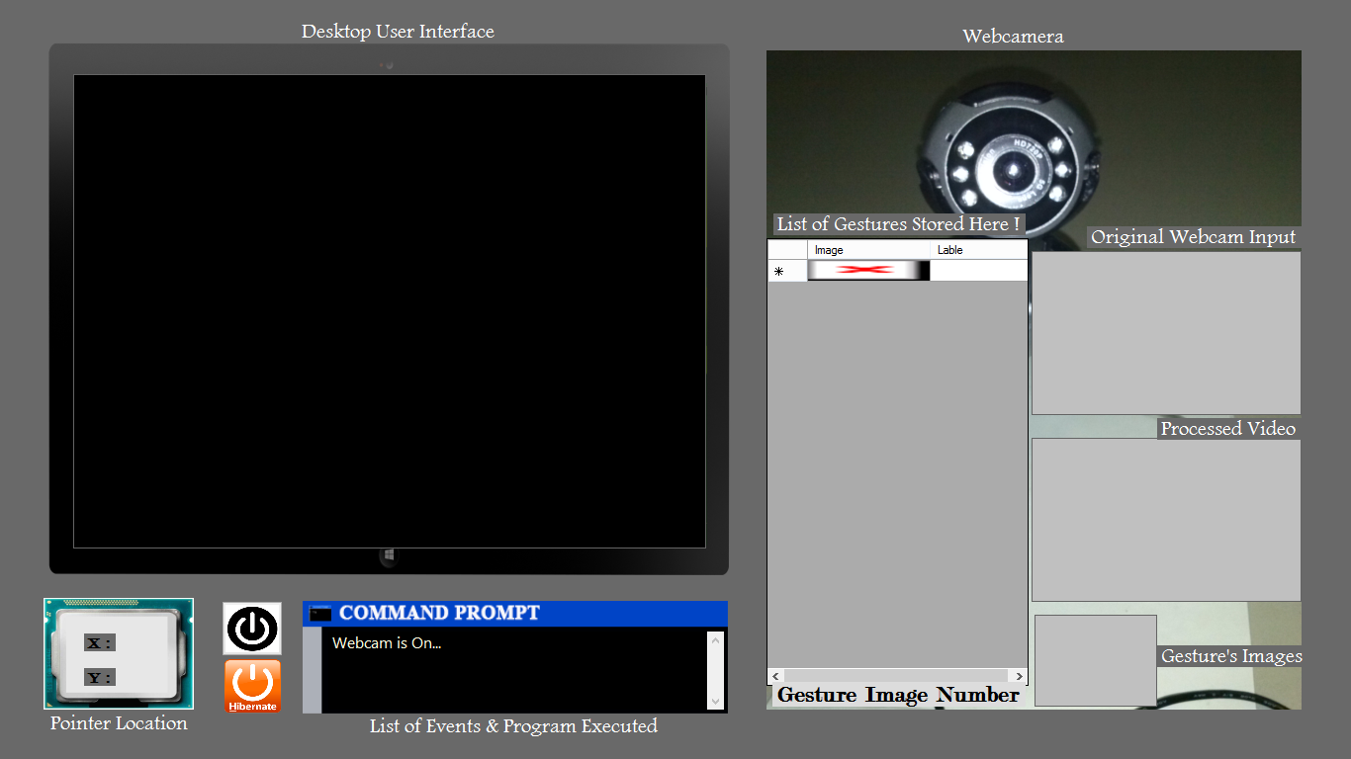

**Figure 4.1: Main Screen of System**

Here in above figure 4.1, ‘Desktop User Interface’ is used to simulate normal desktop. Also the ‘Command Prompt’ and switch buttons as normal buttons on computer’s CPU box. Datagriedview is used to store list of ‘Gestures’ and their assigned application and other Camera Screens like ‘Original Webcam Input’ and ‘Processed Video’ is used to track the marker. Processed Video is Gray frame processed frame output. For Gesture Comparison, ‘Gesture’s Images’ frame is used to get referenced. It is also equalize histogram and similar images are present in Datagriedview.

ii. Marker is placed on index finger

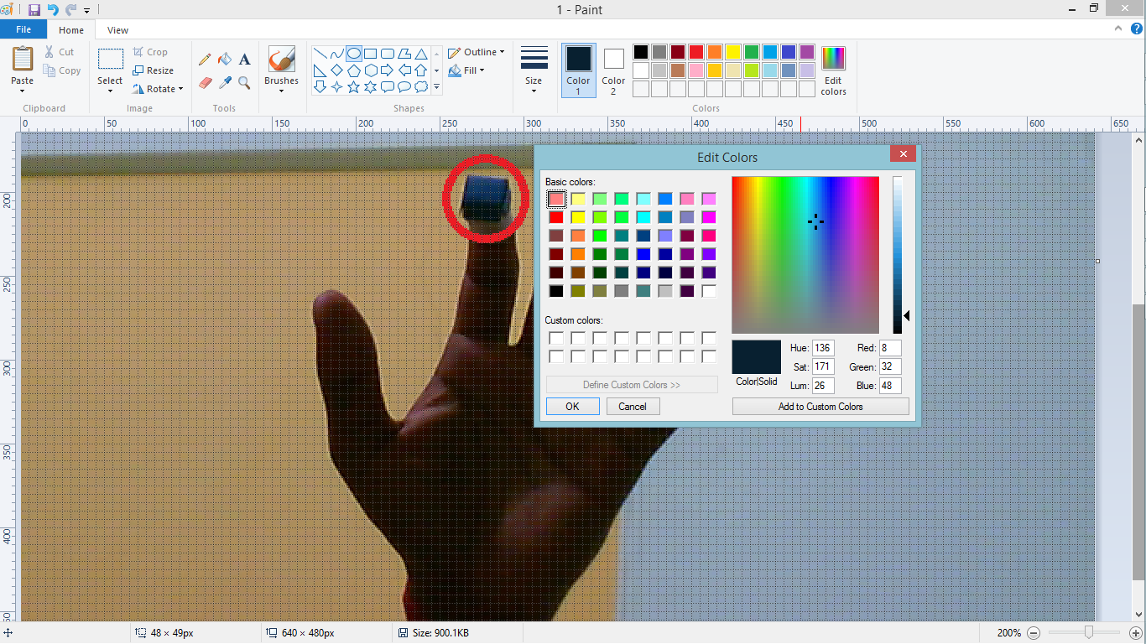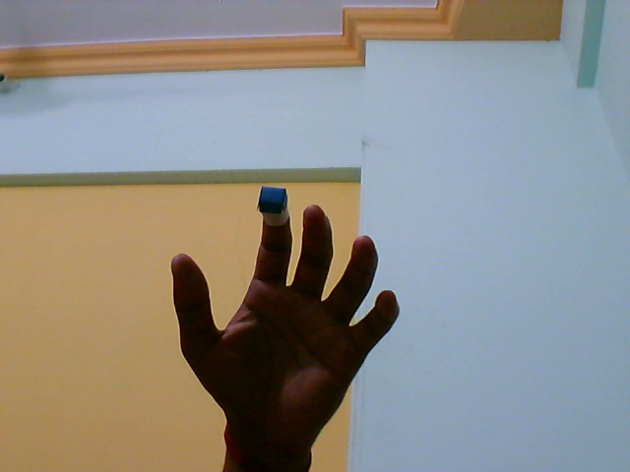

**Figure 4.2: a) Marker on Index Finger; b) RGB values of markers**

Wear any color of marker, in above figure 4.2-a, dark blue marker is used. This color is chosen to show that this tracking algorithm can work with problem of color similarity between background colors. RGB values 8, 32, and 48 using Paint application with color picker tool in Figure 4.2-b.

iii. After pressing the start button, Loading Screen will be popup.

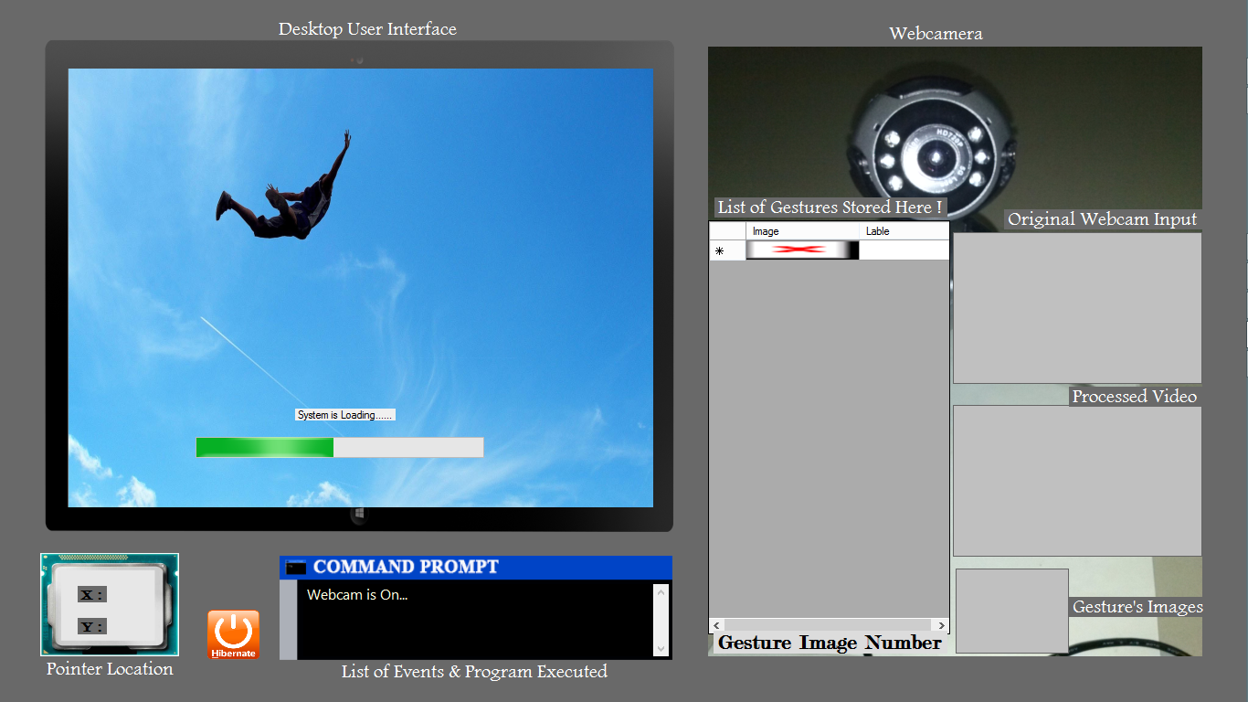

**Figure 4.3: Loading Screen**

iv. Here, you have to set your marker inside black box to get your marker’s RGB Values for tracking purpose i.e. the RGB Program. User can retry this step by pressing ‘Restart’ button.

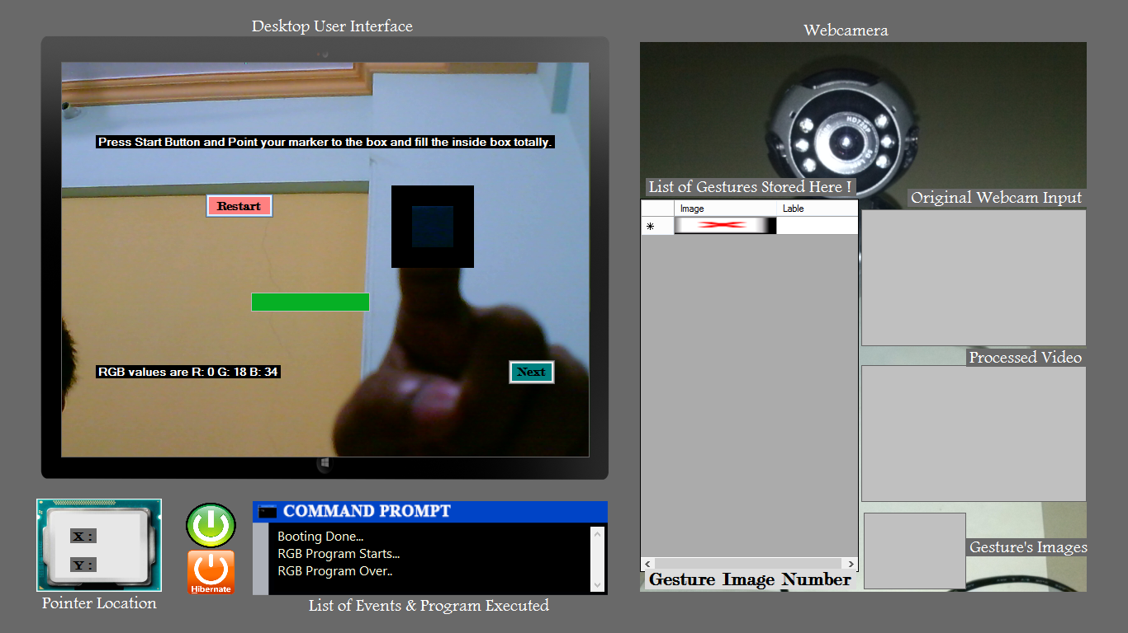

**Figure 4.4: Start RGB Program**

Figure 4.4 has RGB 8, 18 and 34. and figure 4.2-b with 8, 32, and 48, quite same.

v. Gesture Screen is on by pressing Start Button.

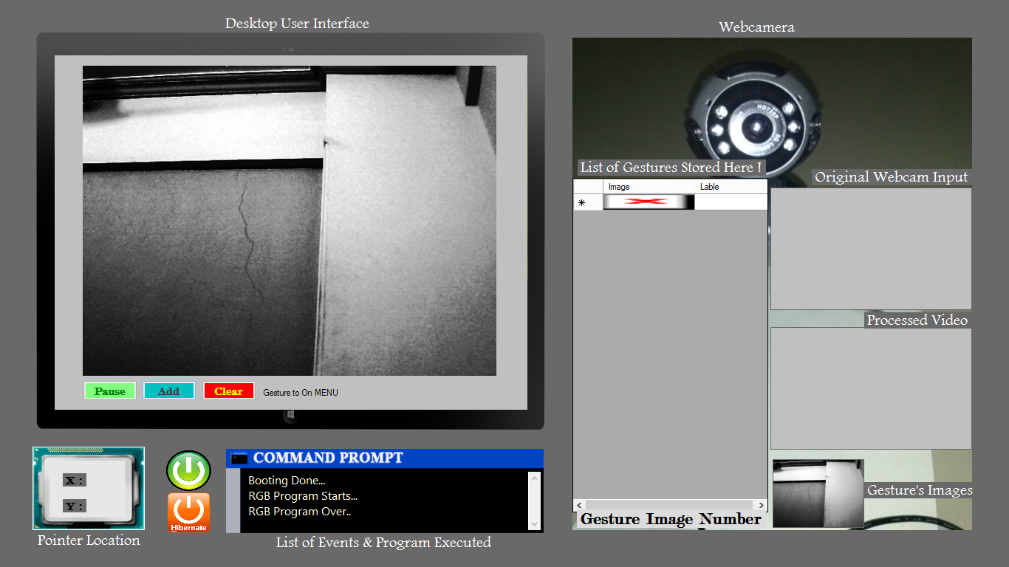

**Figure 4.5: Gesture Process Started**

vi. Add Gestures to applications.

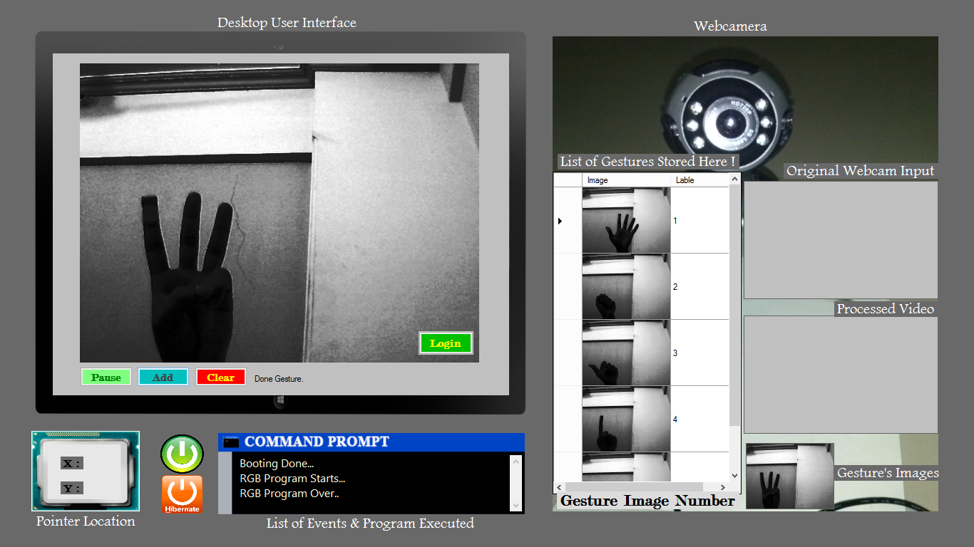

**Figure 4.6: Gesture Addition**

As shown in figure 4.6, many gesture images are added into the Datagriedview with their respected application ids. Only 5 gestures are entered.

vii. This screen will be the working screen of the whole system. After RGB of marker and adding gestures into the Datagriedview, this will launch the program as shown in figure 4.7.

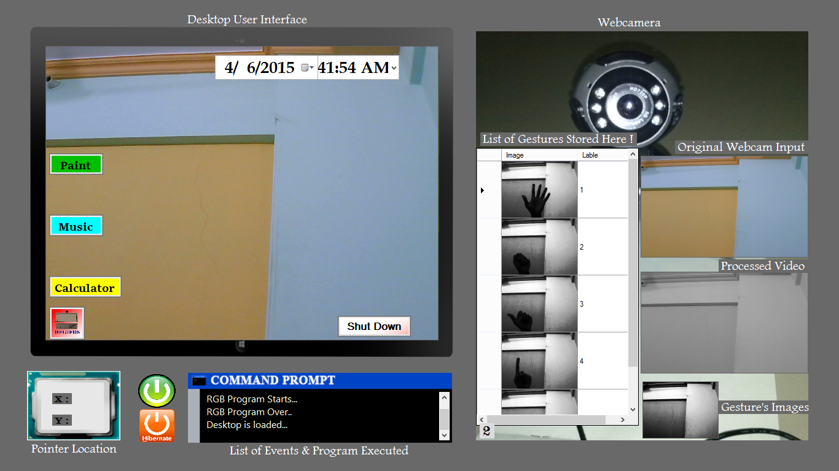

**Figure 4.7: Desktop is loaded**

viii. Finger Tracking Started

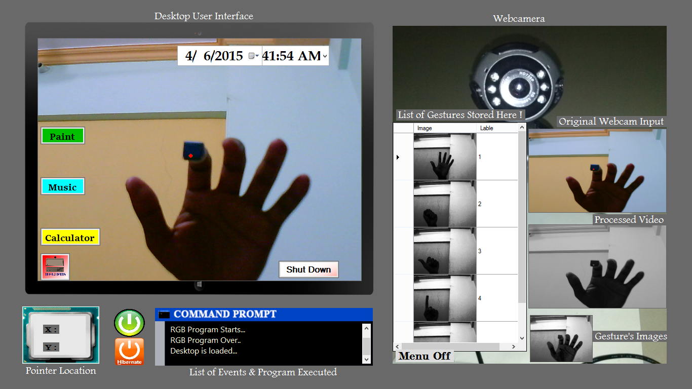

**Figure 4.8: Finger Tracking Started**

As shown in above figure 8, the marker in index finger has a red dot which is used to get the tracked colour pixel from marker. It is difficult to get mouser pointer inside the screenshots. Similar color screen is loaded in ‘Original Webcam Input’, ‘Processed Video’ and Gesture’s Images.

ix. To load application, the marker has to move on any application icon, in figure 4.9 ‘Calculator’.

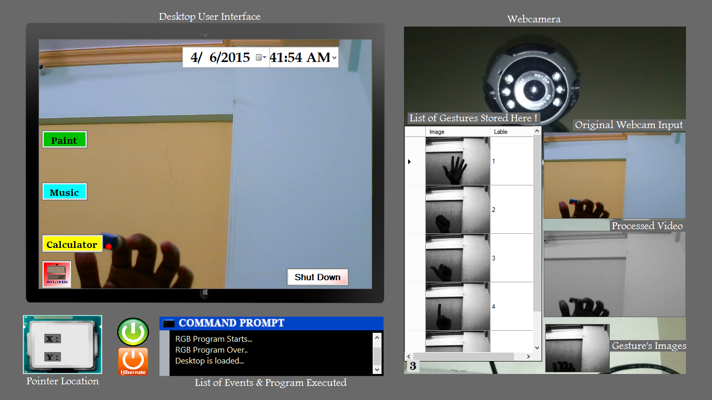

**Figure 4.9 a) Load Calculator**

In this step, calculator is loaded and popped up on desktop user interface as shown in figure 4.9.

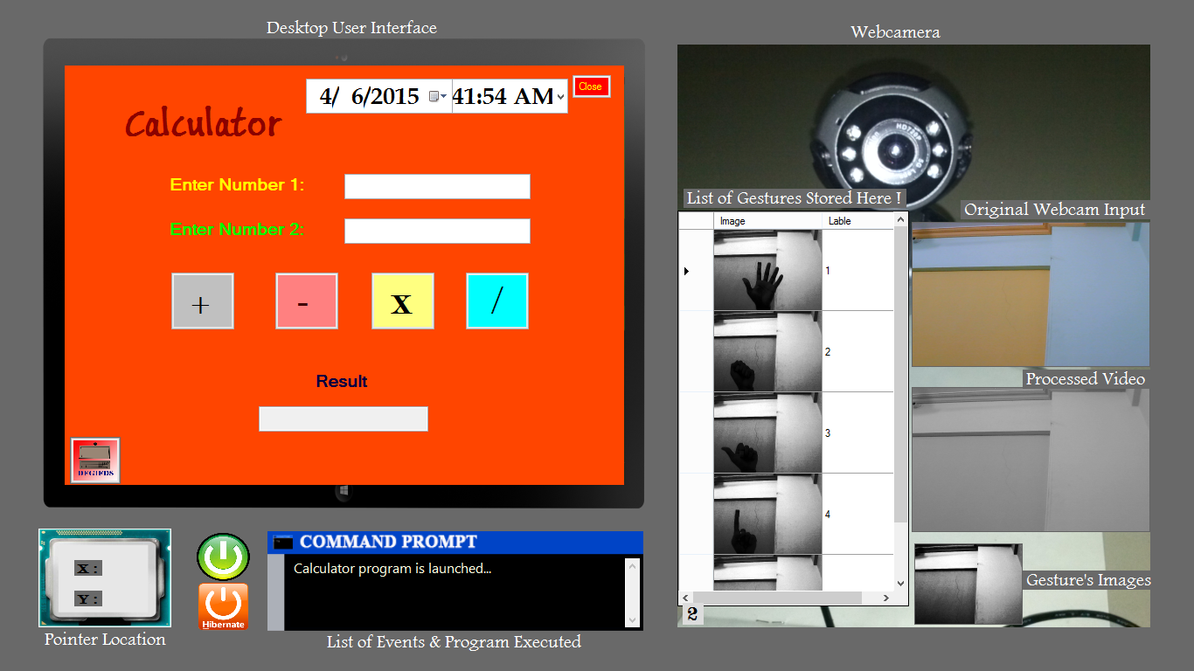

**Figure 4.9 b) Calculator is loaded**

x. Enter Values in Calculator

By simply hovering mouse over the textbox, it will get focus and put cursor at that textbox automatically as shown figure 11. Just enter the value using keyboard.

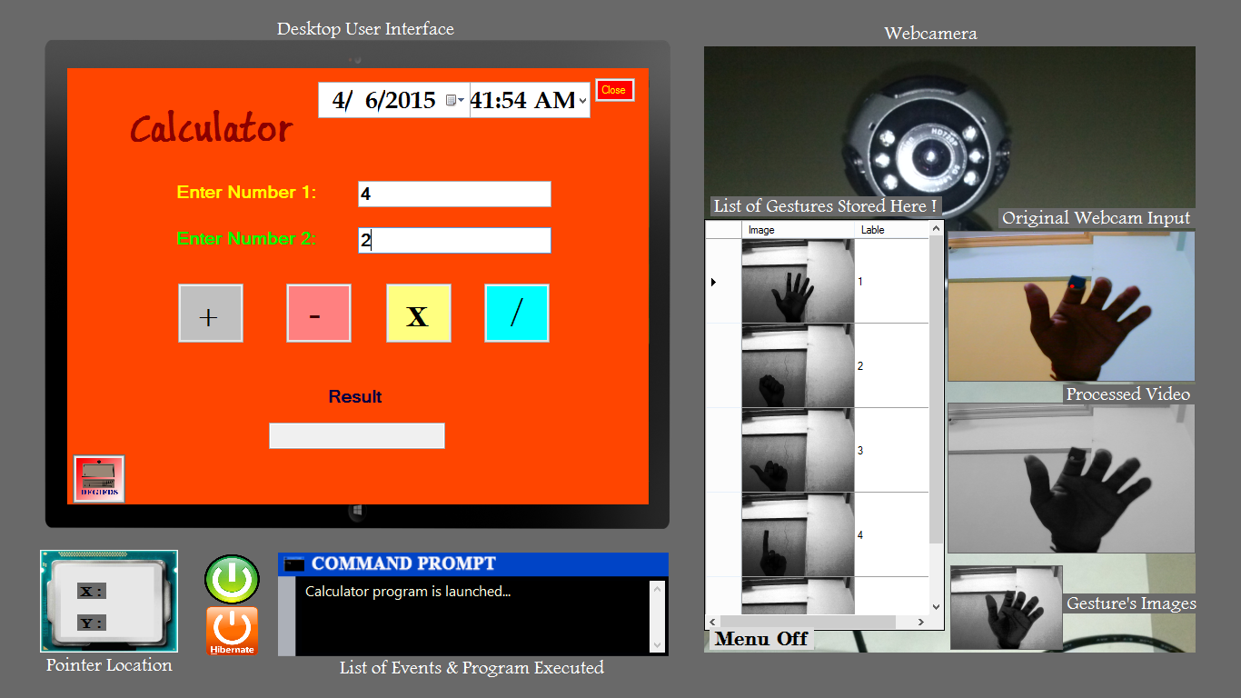

**Figure 4.10: Enter Values in Calculator**

xi. Select any operator by hovering or moving your marker over it.

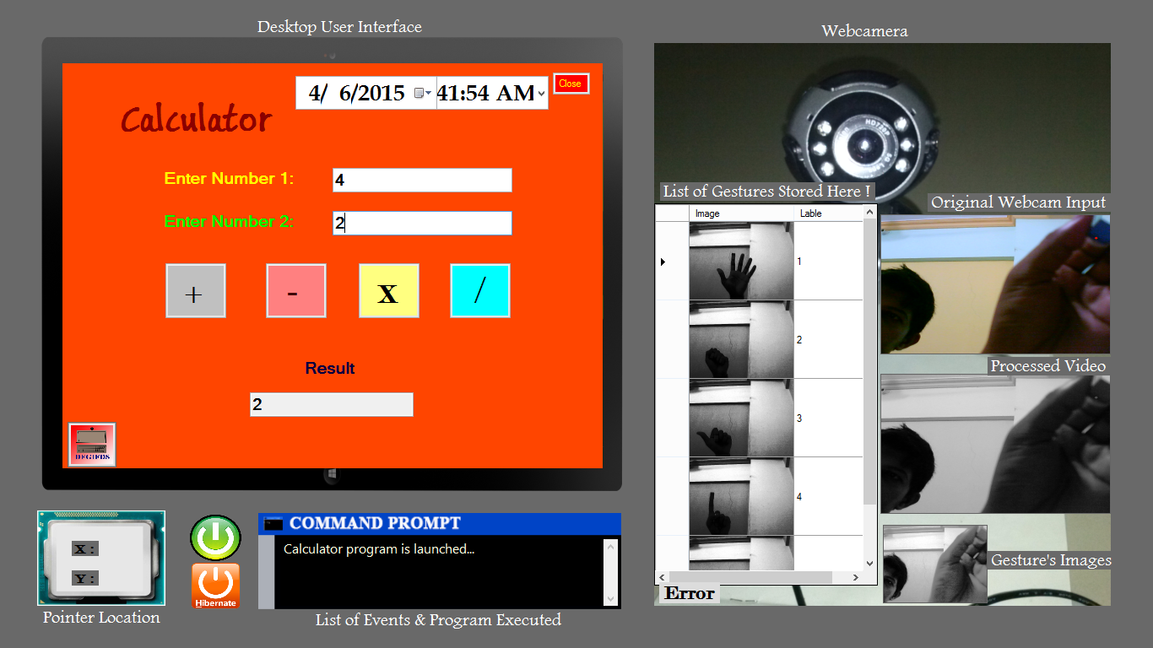

**Figure 4.11: Calculator Result**

Calculator will give the result after pointing the respected operator button. In above figure 4.11, 4/2 is giving result 2.

xii. Close Calculator

By taking mouse pointer or marker position to upper right corner as shown in figure 13, there is button to close this Calculator Application.

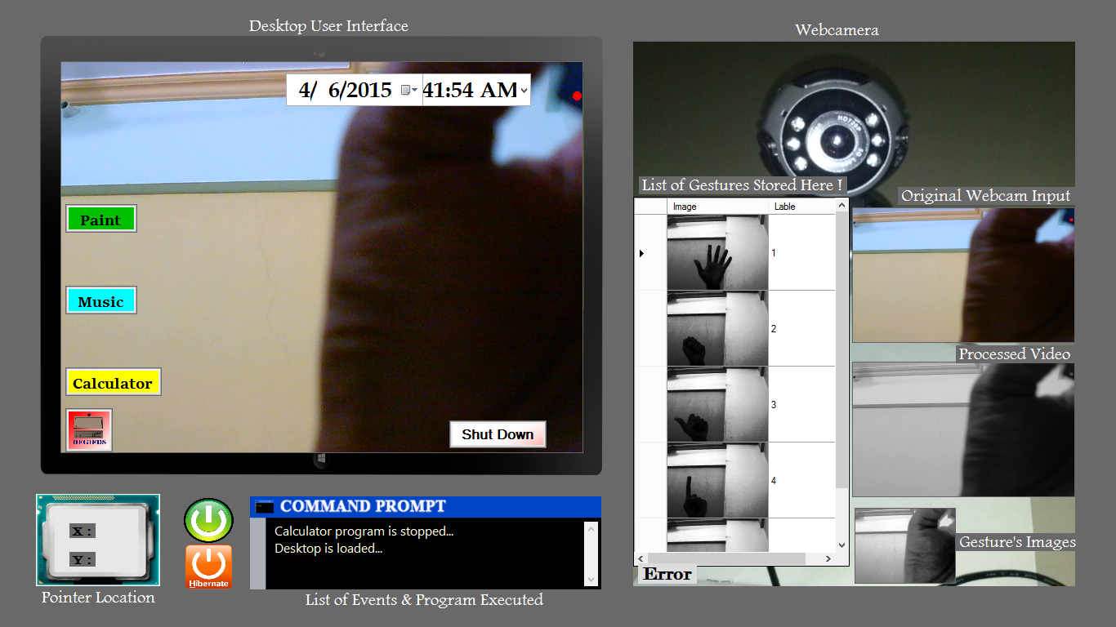

**Figure 4.12: Close Calculator**

xiii. Music Player Launched

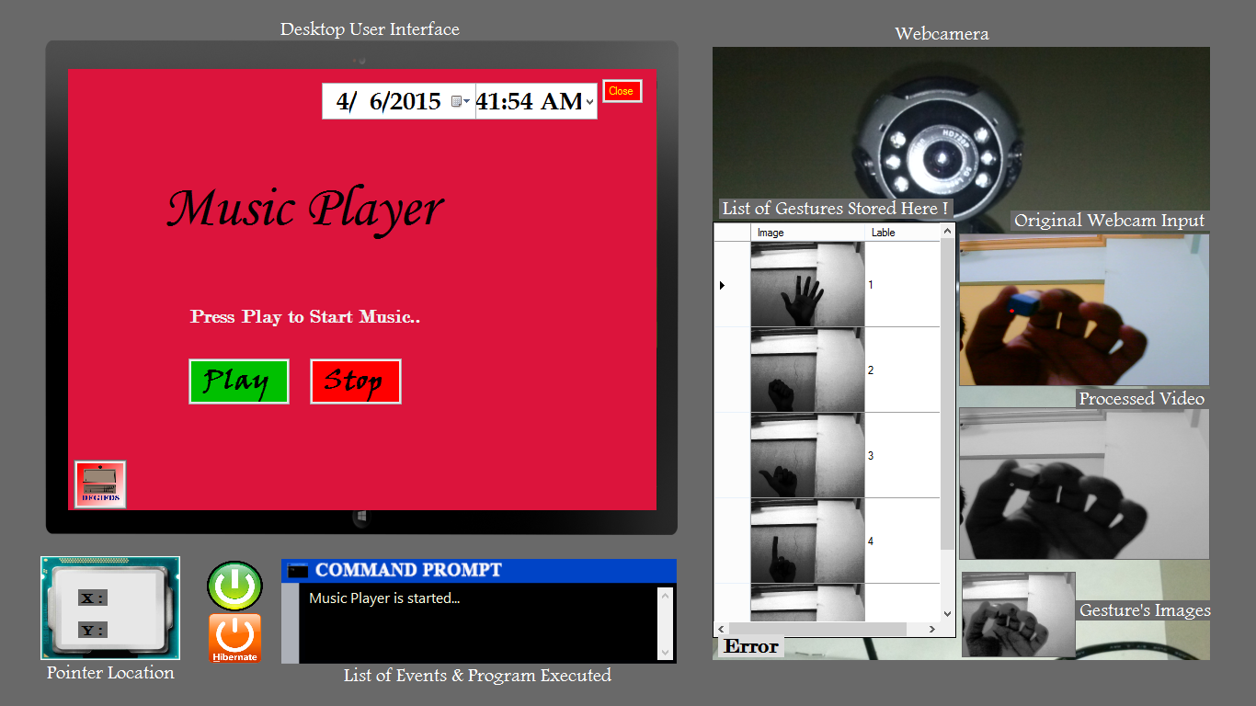

**Figure 4.13: Music Player Launched**

By hovering marker over Music Button the Music Player is launched. By hovering on ‘Play’ button, song will be played and ‘Stop’ will stop the song, as shown in figure 4.13.

xiv. Load Paint

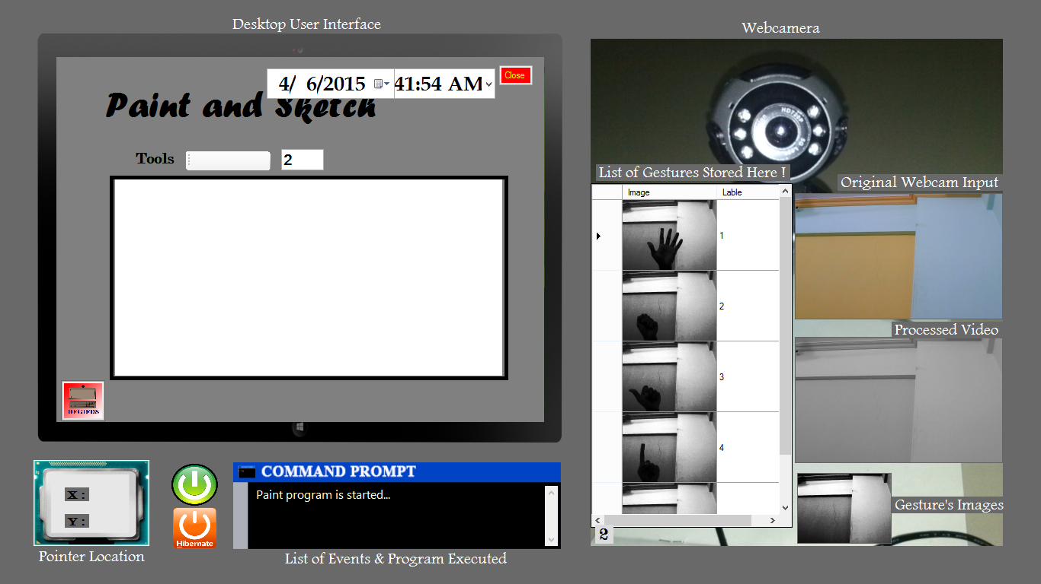

**Figure 4.14: Paint Application is loaded**

This application has a paint canvas on which, the image will be draw figure 4.14.

xv. System Shutdown

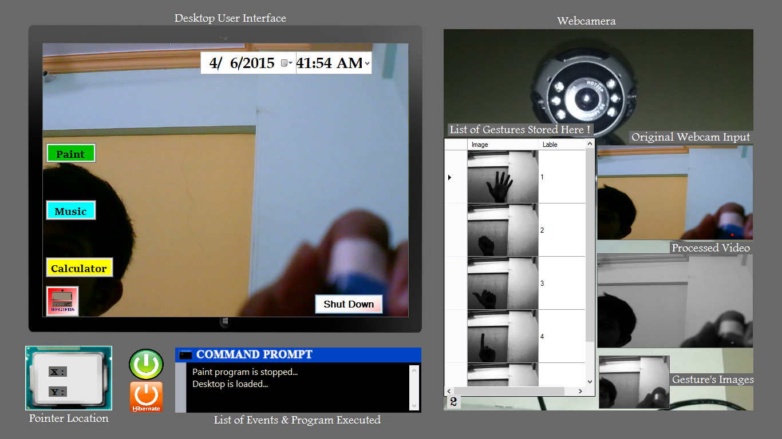

**Figure 4.15: System Shutdown**

‘Shutdown’ button is used to shut down the system as usual. In above figure 4.15, marker is pointed to Shut Down button.

xvii. System is turned off

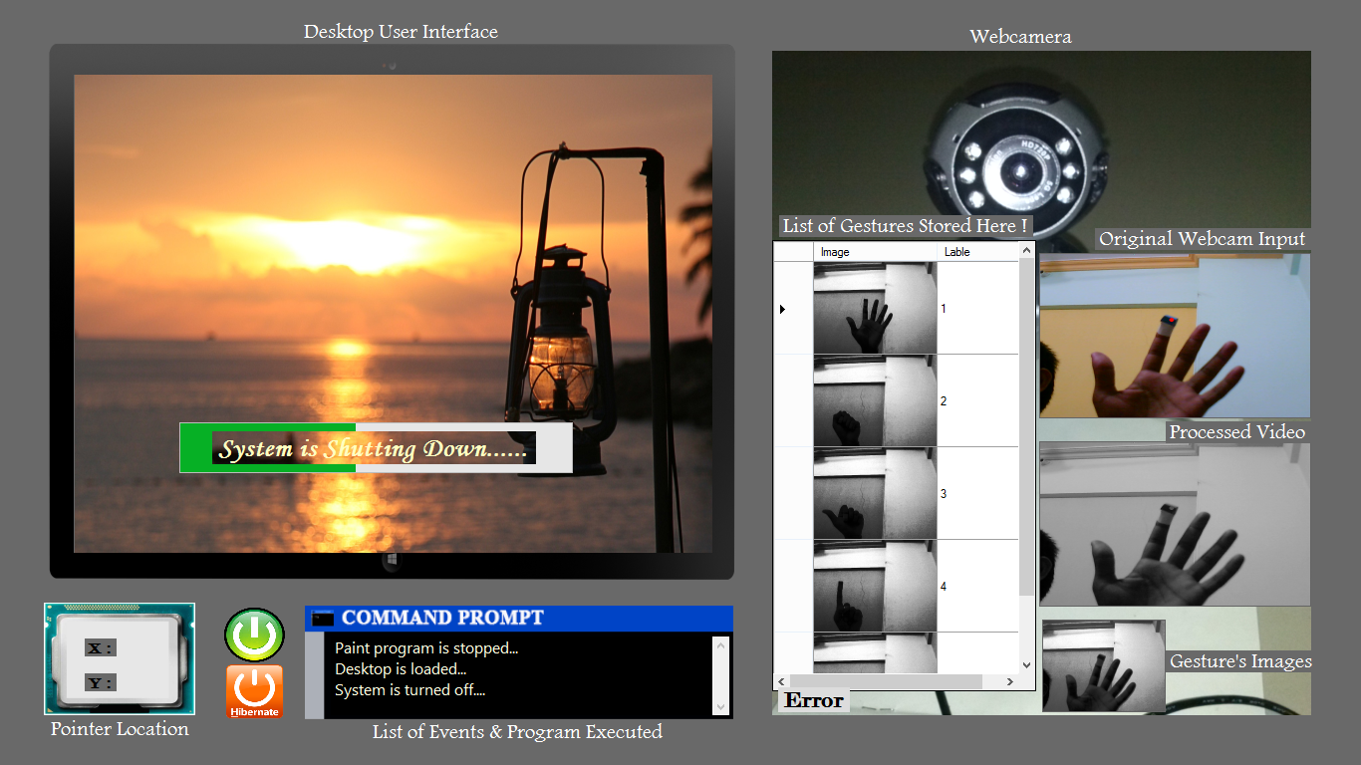

**Figure 4.16: System is turned off**

Here system is turn off, and the command prompt gives the status of turned off also. In figure 4.16, after this shutdown, the application, system is going to shut down but not the computer i.e. used to run this program.

**4.3 Project Comparison**

For this approach, there are some existing projects or softwares developed and availabale in the market. In this module, this project is getting compared with mouseless, Live Gesture Recognition and CamerMouse with table 4.1.

Mouseless:

Mouseless, a computer mouse which interacts with a computer using a mouse in similar way as ordinary mouse but there is no mouse hardware. World knew it as "invisible mouse." This project is developed by Pranav Mistry, Pattie Maes and Liyan Chang. It used IR Camera and IR laser [2].

CameraMouse:

It is free program which is used to control mouse pointer using head movement. This is specially designed for handicapped people. The program of developing this software development is started at Boston University to help people with disabilities like cerebral palsy etc [10][11].

Live Gesture Recognition:

This software detects some gestures. This project is developed by Aamod Kore, Nisheeth Lahoti, S S Kausik and Kshitij Singh Mehlawat from IIT Bombay. In this project, user can wave on application to work with this feature like swipe, wave and create a cyclic loop etc [9].

**Table 4.1: Project Comparison**

|  |  |  |  |  |
| --- | --- | --- | --- | --- |
| Project Names | Project Specifications | | | |
| Algorithm Used | Hardware Used | Technology Used | Other Features |
| Mouseless [2] | - | IR Camera, IR Laser | OpenCV, available for Windows O. S. | - |
| CameraMouse [11] | Template Matching | Standard USB webcam | Assistive Software, Windows O. S. | - |
| Live Gesture Recognition  [9] | Crosshair() method | Camera | OpenCV,  Available for Linux | Dynamic Gestures |
| DFGIFDS  (this project) | InRange() and Eigen  Object Recognizer | Camera | EmguCV,  Windows O. S. | Steady Gestures |

**4.4 Fundamental Requirements**

To make a successful working system, there are some requirements which the system should have and they are as follows:

i. Robustness:

Vision based information is very noisy and very high with respect to the speed and the size. There are some problems like changing illumination, changing clutter and also dynamic Background. Vision-based programs or algorithms must be user independent and robust against all these factors. In this project, to make system more robust, instead of using more than one color, only one color marker is used and algorithm is designed according to it. Also there is facility to choose any color marker and any style of gestures that are going to be entered at the time of loading of the system [3].

ii. Computational Efficiency:

Mostly, this system requires being real-time i.e. with respect to the processing. The algorithms and the methods used for this purpose should be more effective and cost efficient. While developing this project the issue of computation is solved by using threading. Instead of using timer to match the 25 fps frame rate of webcam, thread is used which will be more faster than this frame rate. So it will help to increase sensitivity of mouse and also capable to cope up with more or less number of frame rate input [3].

iii. User’s Tolerance:

Whatever the mistakes or wrong judgments done by the program, should be identified by the system only. These mistakes should not make more loss to the user. To solve this issue, to guide user, every detected and tracked pixel is highlighted by the red dot and given to the screen only. Also for gesture Recognition, the storage also made visible with a video frame for reference to make similar gesture [3].

iv. Scalability:

This system should be easily adapted to many types of applications like this system should be the Sign Language Recognition, same for desktop environments and robot navigation [3].

**Chapter 5**

**Conclusion**

This project is successfully detect and track the finger using marker and also executes the applications by using gestures. For this project, EmguCV is used which gives very robust methods I order to implement the project idea. Also the Eigen Object Recognizer algorithm works very well. Camera is going to become the only one input device in future.

**5.1 Project Goals**

The goal of this project is to create software which can detect human hand and track the finger to control the cursor movement and also provide features existing mouse. The developed system also contains gesture based application execution mechanism. All the requirements are completed and the proposed UI in the project works very well.

**5.2 Future Work**

Collection of additional gesture information: The project proposed system with EigenObjectRecognizer is alone sufficient but it is face detection method and the similar methods are licensed. In order to solve this issue, extra information about this problem solution would have to be gathered and new approach has to be designed.

Removal of Marker: Since the marker based recognition technology solves the issue of robustness but to make this system more familiar to user, new marker less approaches has to be discovered and used.

Use of HSV color system: HSV and YUV domain has more color space than RGB system, so to make better system, instead of RGB HSV has to be used.

**References**

1. Siddharth S. Rautaray, Anupam Agrawal, “*Real Time Multiple Hand Gesture Recognition System for Human Computer Interaction*”, I. J. Intelligent Systems and Applications, 2012.
2. Shany Jophin, Sheethal M.S., Priya Philip, T. M. Bhruguram, “*Gesture Based Interface Using Motion and Image Comparison*”, International Journal of Advanced Information Technology (IJAIT), 2012.
3. G. R. S. Murthy, R. S. Jadon, “*A REVIEW OF VISION BASED HAND GESTURES RECOGNITION*”, International Journal of Information Technology and Knowledge Management, 2009.
4. Susan Goldin-Meadow, "*The role of gesture in communication and thinking*", Gathercole–Development of short-termmemory, PII: S1364-6613(99)01397-2, Trends in Cognitive Sciences – Vol. 3, No. 11, November 1999.
5. Ying Wu, John Y. Lin and Thomas S, "*Capturing Natural Hand Articulation*", In Proc. of IEEE Int'1 Conf. on Computer Vision, Vancouver, Canada, 2011.
6. Harshith C, Karthik R. Shastry, Manoj Ravindran, M. V. V. N. S Srikanth, Naveen Lakshmikhanth,, "*SURVEY ON VARIOUS GESTURE RECOGNITION TECHNIQUES FOR INTERFACING MACHINES BASED ON AMBIENT INTELLIGENCE*", International Journal of Computer Science & Engineering Survey (IJCSES) Vol.1, No.2, November 2010.
7. Noor A. Ibraheem & Rafiqul Z. Khan, "*Vision Based Gesture Recognition Using Neural Networks Approaches: A Review*", International Journal of human Computer Interaction (IJHCI) ), Volume (3) : Issue (1) : 2012.
8. Gary Bradski and Adrian Kaebler, "*Learning OpenCV Computer Vision with OpenCV Library*", September 2008, Fist Edition.
9. Aamod Kore, Nisheeth Lahoti, S S Kausik and Kshitij Singh Mehlawat, ITSP, "*Live Gesture Recognition*", STAB IIT Bombay, May - June 2012.
10. James Gips, Margrit Betke, and Peter Fleming, "*THE CAMERA MOUSE: PRELIMINARY INVESTIGATION OF AUTOMATED VISUAL TRACKING FOR COMPUTER ACCESS*", Rehabilitation Engineering and Assistive Technology Society of North America, RESNA Press, pp. 98-100.
11. Margrit Betke,J ames Gips, "*The Camera Mouse: Visual Tracking of Body Features to Provide Computer Access for People With Severe Disabilities*", IEEE TRANSACTIONS ON NEURAL SYSTEMS AND REHABILITATION ENGINEERING, VOL 10, NO 1, MARCH 2002.
12. Tariq Al-Rayes, "*Studying Main Differences Between Linux & Windows Operating Systems*", International Journal of Electrical & Computer Sciences IJECS-IJENS Vol:12 No:04.
13. Gaston C. Hillar, "*C# 2008 and 2005 Threaded Programming: Beginner's Guide*", Publishing, 2009.
14. Technical Brief, "*NVIDIA® OpenCL™ JumpStart Guide*", Version 1.0, February 19, 2010. iball team.
15. Matthew Helmke, Amber Graner, "*The Official Ubuntu Book Seventh Edition*", ISBN-13: 978-0-13-301760-1, 2012.
16. Windows 8.1 Support Center, "*Getting Started with Windows 8.1*", Lenovo & Windows 8.1 product guide.
17. Education and Training Team, "*Windows 7 Beginners guide*", 2011 Charles Sturt University.
18. Skander, "*EMGU CV Tutorial*", UB CS550 2012.
19. “http://psychology.about.com/od/nonverbalcommunication/ss/understanding-body- language_5.htm#step-heading”, last viewed on 20/03/2014.
20. “http://tech.integrate.biz/openni.htm”, last viewed on 19/12/2014
21. “http://www.microsoft.com/en-in/download/details.aspx?id=23507”, last viewed on 21/03/2014
22. “https://www.nuget.org/packages/EmguCV.221.x86/”, last viewed on 18/10/2014.
23. “https://msdn.microsoft.com/en-us/library/system.drawing.bitmap.getpixel(v=vs.110).aspx”, last viewed on 02/11/2014.
24. “http://www.emgu.com/wiki/files/2.0.0.0/html/07eff70b-f81f-6313-98a9-02d508f7c7e0.htm” last viewed on 03/08/2014.
25. “http://msdn.microsoft.com/us/library.system.windows.forms.cursor.position(v=vs.110).aspx”, last viewed on 24/12/2014.
26. “http://www.emgu.com/wiki/files/1.3.0.0/html/9870fdae-b05b-4d1d-30bd-db363242a08a.htm”, last viewed on 20/11/2014.
27. “http://www.emgu.com/wiki/files/2.3.0/document/html/d556747e-4598-4434-d05a-ed40a229eafe.htm”, last viewed on 21/11/2014.
28. “http://www.cmake.org/”, last viewed on 11/12/2014.
29. Rafael C. Gonzalez, Richard E. Woods, "*Digital Image Processing Third Edition*", 2008 by Pearson Education, Inc

**Publication**

Naik P. D, Tiwari A. R, Dubey A. D, Vartak P, “*Device-Free Gesture Interaction for Desktop System*” proceedings of National Conference on Role of Engineers in Nation Building (NCRENB), March, 2015.